BONDED FIBREGLASS RETAINER

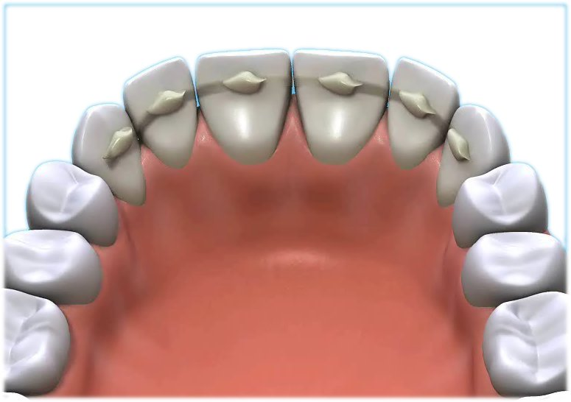

Q What is a bonded fibreglass retainer?
A A bonded fibreglass retainer is a tooth coloured strip of material fixed to the inside of your bottom or top front teeth.

Q How does the bonded retainer work?
A The bonded fibreglass retainer works as a support to the teeth to prevent them moving out of line after the removal of a brace. The fibreglass adds strength to the composite filling material that is used. It makes it rigid enough to hold the teeth straight.

Q What are the advantages of having a fibreglass retainer as opposed to a wire retainer?
A The bonded fibreglass retainer is less obtrusive and visible than a bonded wire retainer. The bonded fibreglass retainer is tooth coloured.

Q Will it hurt?
A There should be no pain or discomfort.

Q How do I clean my teeth & the retainer?
A Extra care must be taken when cleaning your teeth and the fibreglass retainer.

Q How long will the retainer need to be in place?
A The bonded fibreglass retainer would best be regarded as permanent.

Q Will there be any permanent damage?
A The bonded fibreglass retainer will not cause any damage but poor dental hygiene around the retainer will. Poor cleaning and too many fizzy drinks can cause permanent decay marks.

Q How often should I return for check-ups?
A The bonded fibreglass retainer can be checked by your family dentist at your usual check ups.

Q Is the treatment permanent, or will I need additional future treatment?
A Everyday wear and tear will necessitate the repair or replacement of the fibreglass retainer at some future date. Your dentist at your regular check ups will discuss this with you

Q How successful will it be?
A As the bonded fibreglass retainer is both fixed and permanent it is more reliable than a removable retainer.

